EF 8.0 HOL

Lab 3: Using EF Core CLI to Create and Apply Migrations
Objective:
To learn how to use EF Core CLI commands to create migrations and apply database schema changes.
Commands Used:
- Install EF Core CLI:
dotnet tool install --global dotnet-ef
- Create migration:
dotnet ef migrations add InitialCreate
- Apply migration:
dotnet ef database update
Result:
The migration was successfully created and applied. The RetailInventoryDB database was created in SQL Server with the following tables:
- Categories
- Products
- __EFMigrationsHistory
Conclusion:
Successfully used EF Core CLI to manage database schema creation and apply migrations in the Retail Inventory System.

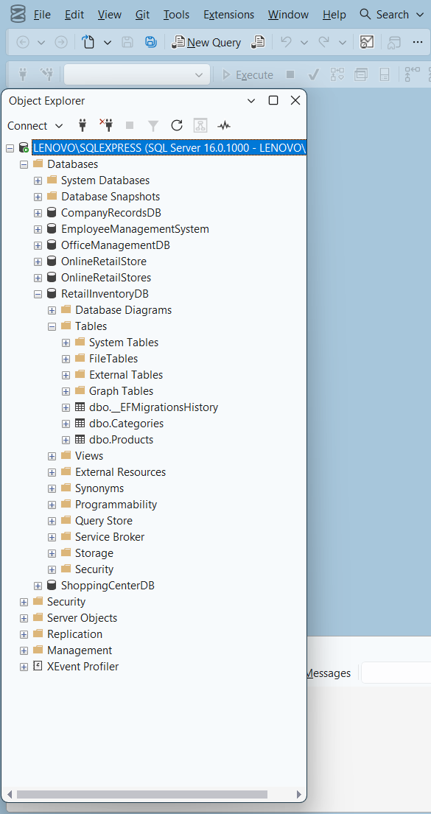
Outputs:

